2019_6th JOINT_ ETSAC-UDC (Spain), HIT (China) and IMUT (China)

Introduction to the course program:

In the years in which the exercise to be developed has been proposed by ETSAC, we have tried to insert it within the scope of exploring urban realities that open up to possible futures, due to various causes, financial or industrial crises, obsolescence of the activities developed there, environmental improvements, population dynamics ... In short, a wide range of causes that open the debate on how to act, what to plan, etc., and where, in recent years, there has been a demand for citizenship to participate in that decision-making process.

Along with an awareness of the intergenerational responsibility that we have in terms of not mortgaging the future of a scarce good as is the land for generations to come.

We have kept in mind that this type of calls and competitions, in Europe represented by EUROPAN, is a scenario where future professionals test their ability to propose strategies, which cover a multiplicity of scales, which also makes it possible as a teaching objective in our Joint to approach specific programs, which allow to develop exercises that adjust to the diverse contents of the curricula of the participating faculties: ETSAC-UDC, HIT and IMUT.

In A Coruña, as if the urban and social reality were added to our academic research, the subject of work of the course, launched and developed in 2016 on the port area, is today one of the fundamental issues of debate. Recently a contest on the coastal area of ​​our port has been launched to propose strategies of action on it.

For the preparation of the contest several works have been developed on the area, with what the information, ideas, proposals etc. have increased a lot. Added to the completion in this elapsed time of citizen discussion forums.

Understanding the coastal area only as those lands under the jurisdiction of the Port Authority of A Coruña, seems unsustainable and absurd from a much more complex and interconnected reality.

The rethinking of the natures of the city, the necessary rebalances within it from all optics and relationships, physical, social, infrastructural, environmental, etc., from a position that understands the metropolitan territories as a whole, provides the opportunity to collect and rethink the underlying wealth in the place.

Within the wide range of possibilities we have chosen to work during this semester in an area and a concrete situation where this broad view is inevitable and urgent.

The neighbourhood of Os Castros in A Coruña exemplifies well what happened with the occupation of the coast, its transformation and reconstruction and its consequences. It enables the teacher to specify a program and know a story and a culture. Assessing the consequences of development through history and how the following generations inherit and we must analyse and question certain decisions that were made based on a not valid logic.

Program to develop:

The release of former uses of the large landfills where liquid bulk facilities are located today opens up all kinds of needs for the study of alternatives on several fronts. The construction of the city and its infrastructures is facing the debate today about its nature and the sustainability of the system as a human settlement.

We propose this year through the construction of an architectural piece-infrastructure, re-activate the relationship between areas, the neighborhood and its coastline, which had until a few decades ago; while reformulating the relationship with the city and its physical, economic and cultural landscape.

The "building", understood as a mixed program architecture, will gather, among other functions, a transport interchange taking advantage of the debate about the future of the San Diego railway station, a social-equipment centre (day centre, municipal management, etc.) , and other functions that could be suggested as pertinent.

We will explore the possibility of transforming in a radical way the relationship between two areas, city and port as we understand today as one but that should at least coexist.

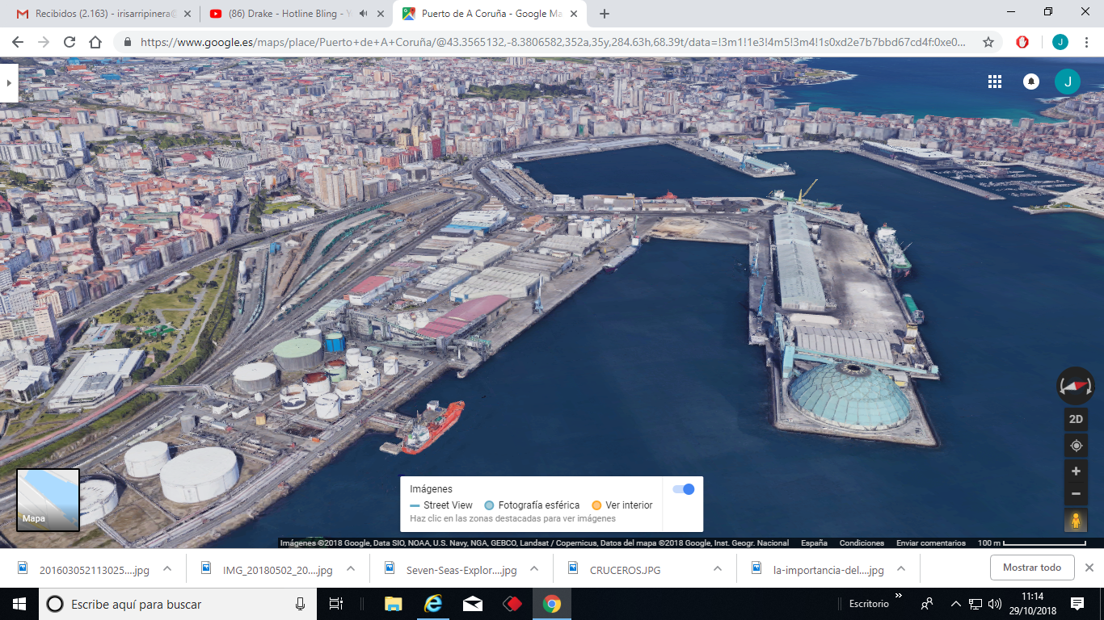

We propose to think of a transport exchanger of a small scale given the existence of the large station-exchanger already at a short distance. It could accommodate light rail or internal coastal transport and it could pick up transits of river boats etc.

And fundamental to understand the opportunity since we are talking about architecture and environment, that the architecture has the power to transform and build the territory and the landscape, and here we find two areas separated by the public administration but whose dramatic separation was helped by the topography of the site .

When we speak of the social center we understand it from the perspective of nowadays, a neighborhood scale that decentralizes the facilities of the city and allows to improve mobility and family conciliation.

The student will be provided with documentation on the historical development of the area, general plans and information on recent plans and works on the area.
This will be discussed previously in the classes.

-Goal:

Develop a proposal for area management, and construction with the program defined at the preliminary project level.

-Dimensional parameters of reference:

Rail exchanger: 750 m2 plus platform operations
Exchanger traffic of river transport: 200 m2
Mixed use social center: 5,000 m2

The necessary urban development and accessibility areas will be added to the previous figures.

